Harry Lemire: Master Fly Fisher & In-hand Classic Salmon Fly Tier
8 ½ x 11, full colour, about 70 pp
After I completed my Peter McVey book I thought about doing one on Harry Lemire. The inspiration for the Lemire book came from McVey as they had been best mates for ½ a century and McVey had many stories about Harry. Lemire was a master steelhead fly fisher and a hell of a fly tier. A single in-hand classic Atlantic salmon fly tied by Harry can sell for hundreds of dollars. Whenever I wanted flies for my fly patterns books he was very generous. The earliest one I have, a Lemire Black Irresistible, in my collection dates back to 1993 which Harry gave me when I was putting together Fly Patterns of British Columbia. As I age I do think about what may happen to those Lemire flies that I have and putting them into safekeeping is another reason for doing a book. I have a book binder who crafts amazing book boxes and I have commissioned her to make a small quantity of book boxes where I can tip in a Harry Lemire fly making the book and fly set in a solander book box a collector’s item. I hope to send the book off to the printers in late August and should have softcover books available later in the fall. Depending on final page count, which determines printing cost, the book should sell for about $20. I am still fiddling with the cover layout and getting a good jpg by scanning a printed pdf cover is not true to colour but it is all I have at the current time.

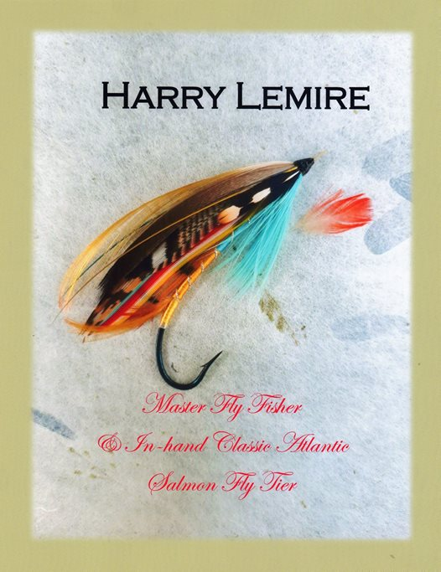

51 Comments
24 Shares

