Miller and Walker Creeks Stewardship
On May 18, 2019 four members of NFA showed up in Burien at the upper section of Miller Creek to improve the area around the stream. The group included Peter Rubenstein, Tom Beaulaurier, Bill Rose, and Wytold Lebing.
Miller and Walker Creeks drain basins adjacent to SeaTac Airport. They join together and empty into the Lower Puget Sound west of SeaTac below Three Tree Point. Salmon returning from the sea to spawn maintain an almost tenuous hold in these two small creeks. The conditions immediately adjacent to these streams have been degraded by invasive species. Large rains and the resulting run off events can kill Coho and wash out fish redds. Restoration work benefits the returning Coho and Chum salmon.
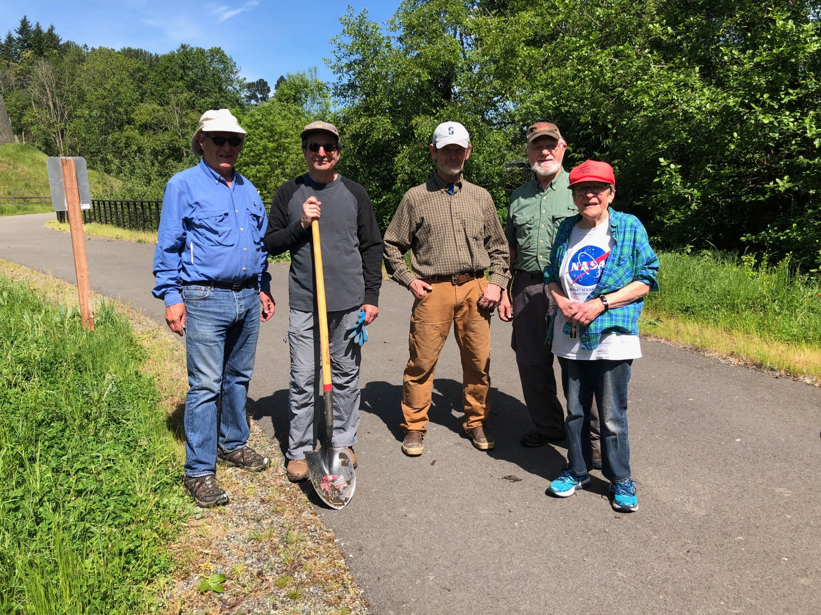
From left to right: Peter Rubestein, T Beaulaurier, W Lebing, B Rose, unknown
The particular section of stream we have been improving is located in a warehouse area which is developing near the airport. Several other warehouses are planned for the area. Development of this sort would normally result in worse run-off during rains. However, the city and county are required to take actions that will lessen the impacts of development. Experiments have shown that passing run-off, which is normally toxic to salmon, through the earthen filters will clean the water. At this site a catchment basin has been created to capture and filter the run off from the warehouses, before reaching the stream.
There will be road work done this summer. This road work will be done in such a way that it minimally disturbs the stream and is timed to avoid the fall spawn. In fact the road construction will replace a problem culvert and hopefully better define the stream as it flows through the area.
It was rewarding to find that the majority of the plantings we put in last fall had survived the winter. We put some extra mulching around the young plants. We also weeded as necessary. One of the nice parts of working on the Miller Walker basin is that we are seeing the effects of our efforts. It may be a long time before all the natural plants are fully grown and protect the stream. But we are rewarded by knowing the work we put in will help returning salmon.

